Note: Include this page only when adding / amending / deleting a document. If using this document as a record, this Revision History page can be omitted.

REVISION HISTORY

Revision no | Date | Description of Changes | Reason for Revision | Revised by | Approved by
2 | 01 Dec 12 | Add revision history page  CPIAR #55, 58, 913 | - Recommendation from Stage 2 audit  - Revised due to CPIAR raised during IQA | RDPlacido
3 | 01 May 14 | Removed some reports | - Improved reporting monitoring efficiency  - Revised due to CPIAR raised during IQA | LDLacuna
4 | 8 Apr 16 | Added disclaimer when printing the document | For document control | RCGanal | MVBergantin
TM-BR-MG-11 Rev02, 10302015

I. Objective
To provide quality candidates to fill-in the vacant position in the organization based on the given specifications and in the agreed timeline.
II. Scope
This procedure defines the action and responsibilities of the Recruitment Specialist and HR Head in the recruitment and placement of candidates. This covers activities from the receipt of the manpower request to submission of report.
III. Definition of Terms
List of Manpower Requests | - It is an online list that contains the details of all manpower requests received by the Recruitment Specialist and HR Head. It shows the date of request, job title, no. of requirements, date needed, vacancy reason, client/assignment, terms of employment, job specifications, requesting party and the names of successful placements.
Sourcing | - Is a process of getting candidates from various means. It could be internally or externally sourced.
Daily Recruitment Report | - Is a daily tracker by the Recruitment Specialist listing the names of the candidates invited for exam up to the end result of the application.  - Is reviewed by the HR Head every end of the week.
PAT, Harvard | - The prequalifying examinations administered to the applicant.
Jung Typology Test | - Assesses the candidate’s aspects in terms of being extravert/introvert, sensing/intuitive, thinking/feeling and judging/perceiving.  - Is an online test administered only for potential regular new hires.
Job Specification | - Refers to the characteristics and qualifications of an employee required in order to perform his duties and task satisfactorily.
Job Description | - Is a list that a person might use for general tasks, or functions, and responsibilities of a position.
201 file | - Is a set of records containing personal information of the employee and other records pertinent to the employment (e.g. application for employment, resume, exam results, interview evaluation, requirements, certificates, etc.).
Bodyshop / Staff Augmentation | - Means outsourcing or deploying of staff to clients’ projects except GENIISYS projects.
RMS | - Is a database of only those who reached the final screening but qualifications do not match the current vacancy, those who took the personality test but is not personality-fit, those who passed CPI’s interview but was not considered by the client and those who declined the job offered.
New Hire Report | - Is a summary list of newly hired employees for a specific cut-off date. It gives information about the name of the newly hired employee, assigned employee number, position, assignment, date of hire and email address.  - It is prepared by the Recruitment Specialist and forwarded via email every 15th and end of the month to the following: HR Head, Administrative Assistant, Finance Head, Payroll Specialist and Accountant, Accounts Payable Accountant and Accounts Receivable Accountant.
List of Pool Report | - Is a pipeline of employees / candidates who are waiting for a client assignment.  - It is presented by the Recruitment Specialist to the ExeCom during weekly meetings and email is forwarded to the ExeCom, HR Head, Project Managers and Account Managers every time there are changes.  - It also includes the list of employees whose project will end, the contract is not renewed and if the pre termination is initiated by the Account Manager or Unit Head.
Deployment Letter | - Is a letter given to employees who will be deployed to the client site specifying the reporting details.
EMS | - Is a database of all employees on-board. It contains employee records about employees’ personal information and employment details.  - It also keeps records of those who separated from the company under its inactive section.

IV. Procedure Details
Responsible | Activity | Interface
Recruitment Specialist / HR Head | 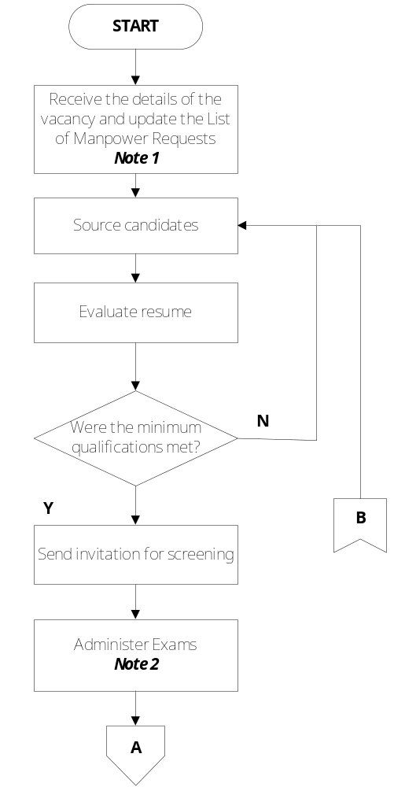 | Requesting Party  List of Manpower Requests  Guidelines for Manpower Sourcing  Applicant’s Resume  Daily Recruitment Report  Application For Employment PAT, Harvard

Responsible |  | Activity | Interface
Recruitment Specialist |  | 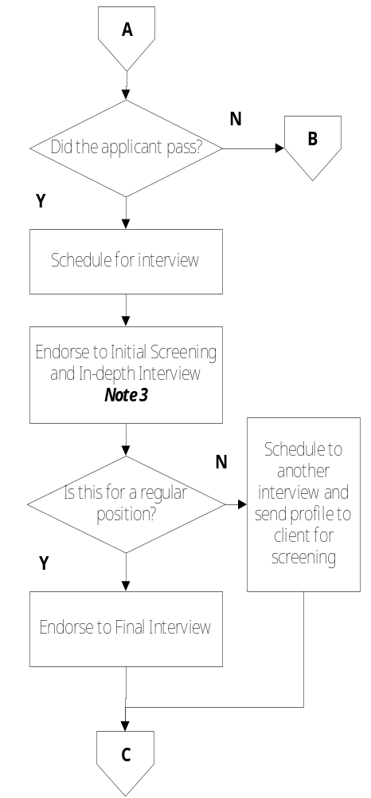 | HR Head Interview Guide Questions  HR Head  Client  President  Interview Guide Questions
Responsible |  | Activity | Interface
Recruitment Specialist  HR Head  Recruitment Specialist |  | 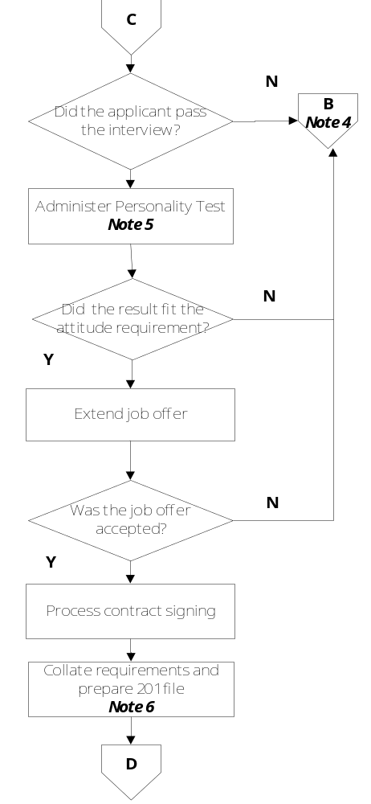 | RMS  Jung Typology Test  ExeCom  Job Offer Letter Schedule of Benefits  Employment Agreement  Job Description  List of Pre-Employment Requirements,  Pre-Employment Requirements Tracker 201 file
Responsible |  | Activity | Interface
HR Head  Recruitment Specialist |  | 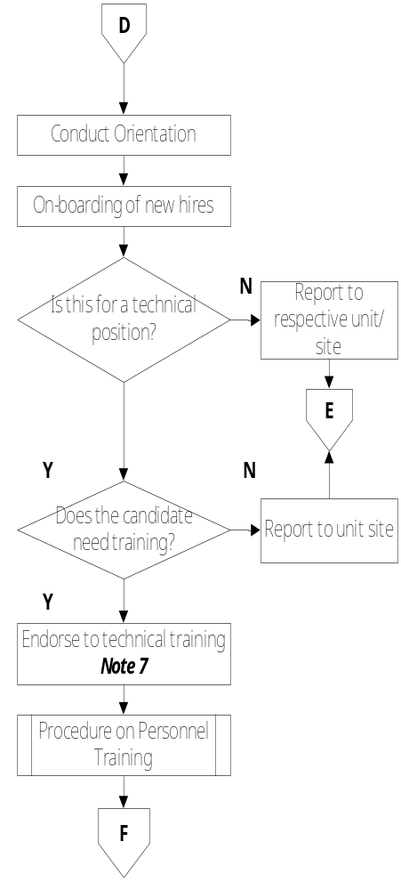 | Orientation Checklist Attendance Sheet  New Hire Report  Administrative Assistant  Finance Unit  Unit Heads / Client  Deployment Letter Client  Guidelines for TESDA Scholars AR Accountant  CIO and IT Head Procedure on Personnel Training
 | Responsible | Activity | Interface
 | HR Head  Recruitment Specialist  HR Head  Recruitment Specialist | 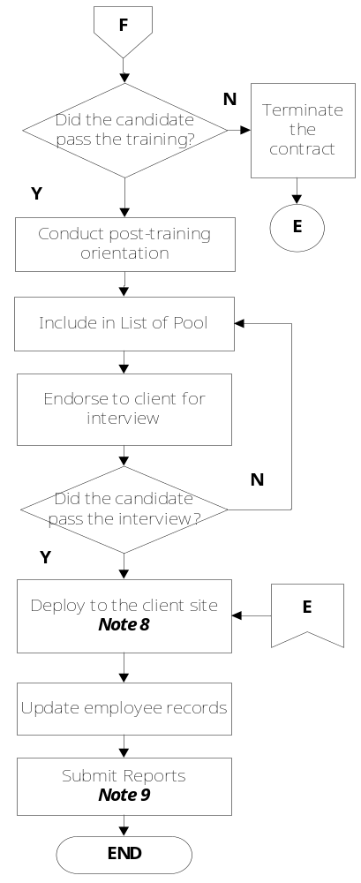 | Guidelines for Employee Termination  Orientation Checklist Attendance Sheet  List of Pool Report ManCom  Account Manager Client  Deployment Letter  EMS  201 File  New Hire Report  List of Pool Report  ExeCom
Notes:
- The Recruitment Specialist and HR Head will be informed by the Unit Heads / Account Managers regarding manpower requests through email or discussed during meetings. The list of manpower requirements will be filled out by the requestor, Recruitment Specialist or HR Head.
- PAT and Harvard Exams are required to those applicants for Developer positions. For Administrative and Non-Development positions, only PAT will be administered. SSCT is administered to candidates, whenever requested.
- HR Head will conduct the initial screening for regular positions; Recruitment Specialist is responsible for screening candidates for contractual positions.
- If the assessment of the interviewer shows that the candidate has the potential but currently does not fit the job requirement, his/her profile will still be kept in the inactive file for future reference.
- Personality test will be taken only by the candidates are considered for a direct-hire position within the company.
- Recruitment Specialist shall maintain a Pre-Employment Requirements Tracker to ensure that all requirements will be submitted by the employees. HR Head will also check if the contracts are duly signed by the employee and co-maker before sending those to notary office.
- If there are TESDA vouchers available, Accounts Receivable Accountant will process the necessary requirements.
- Before deployment of the employee to the client, Account Manager will give an orientation about the nature of work, type of project, client policy and expectations. HR Head will discuss about the HR policies affecting their deployment and will issue the Deployment Letter.
- Daily Recruitment Report is prepared by the Recruitment Specialist and is updated daily.

V. References
- Application For Employment
- PAT
- Harvard
- Jung Typology Test
- Interview Guide Questions
- Interview Sheet
- Schedule of Benefits
- List of Pre-Employment Requirements
- Orientation Checklist
- Procedure on Personnel Training
- Guidelines for Manpower Sourcing
- Guidelines for TESDA Scholars
- Guidelines for Employee Termination
- Work Instructions on TESDA Training for Work Program

VI. Quality Records
- RMS and EMS
- Applicant’s Resume
- List of Manpower Requests
- Filled-Out Interview Sheet
- Job Offer Letter
- Employment Agreement
- Pre-Employment Requirements Tracker
- Attendance Sheet
- Deployment Letter
- Job Description
- New Hire Report
- List of Pool Report
- Daily Recruitment Report
- Updated 201 File

